# Architecture for Humanity

### Ideas and concept:

* Make donation aspect of the organization more evident.
* Create an online store to buy supplies that will be donated to the organization.
* Change color scheme so that website is more inviting and uplifting
* Slogan: Buy a hammer, build a school

### Competitors:

**World Wildlife Fund**

<http://www.wwf.ca/>

* Different coloured button to put emphasis on the donating and the WWF store
* numerous/repeating donation elements throughout website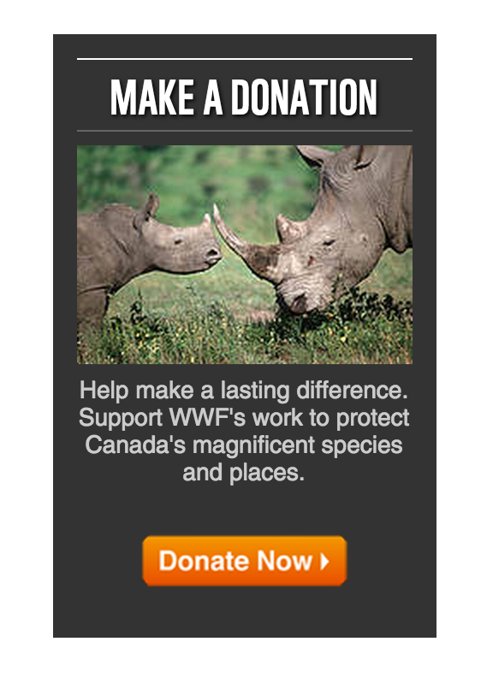
* lots of images showcase work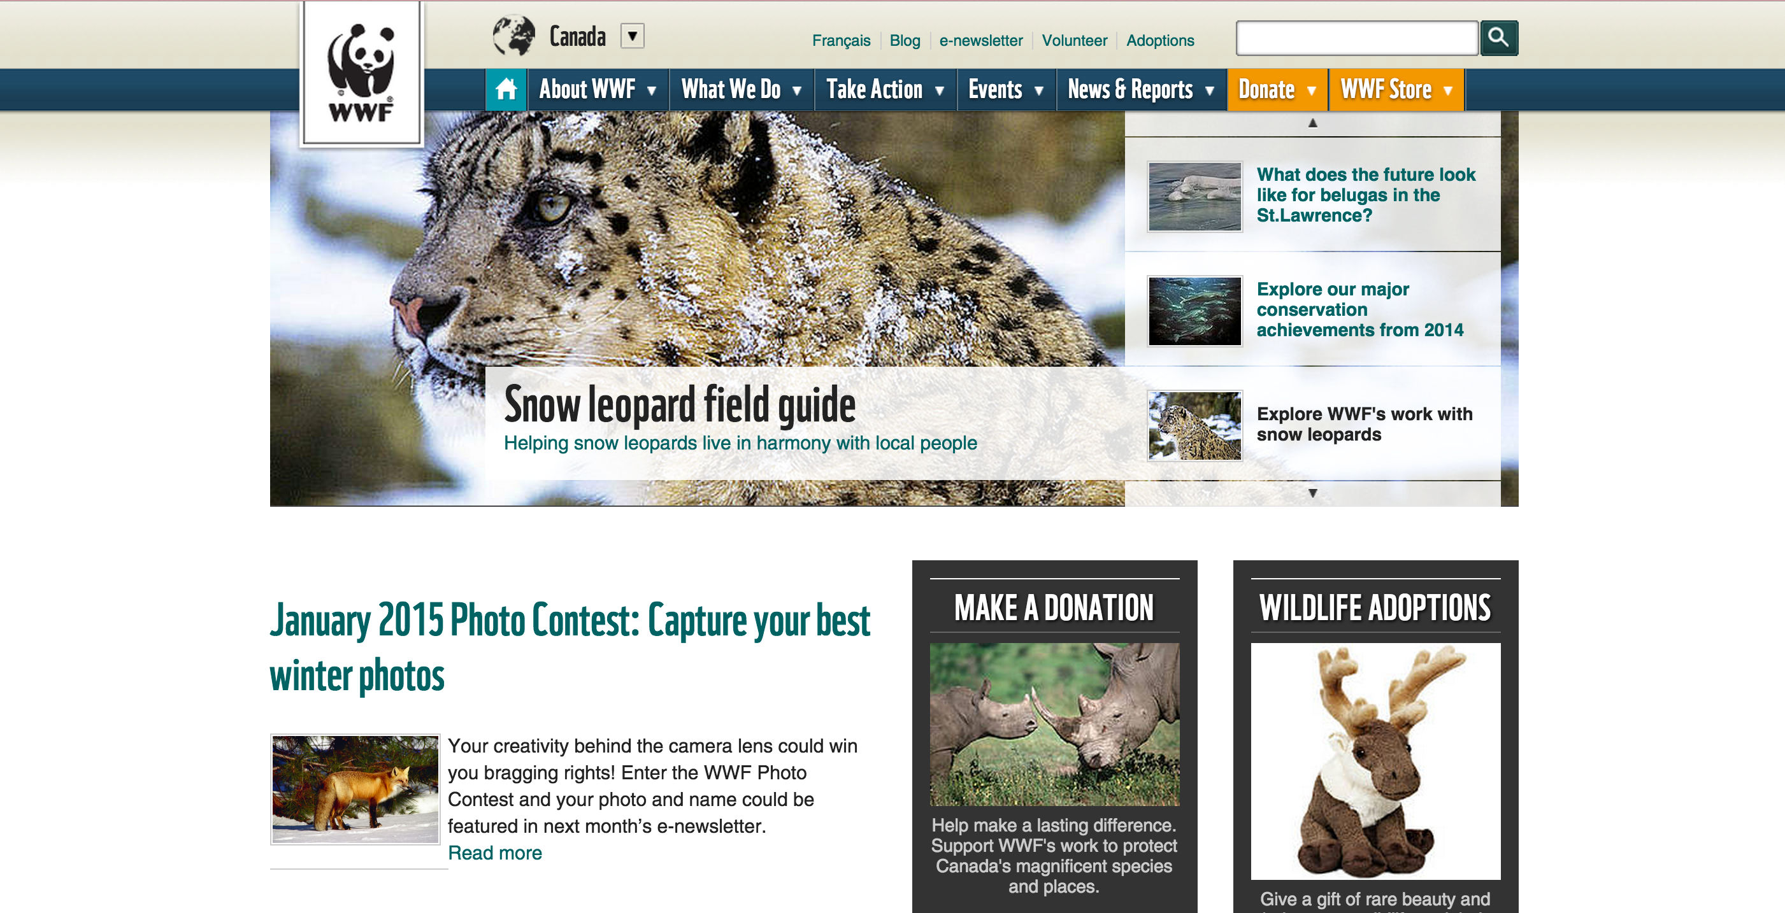

**Unicef**

<http://www.unicef.ca/>

* picture with title and short description dividing different sections
* donate button is number one in navigation list
* banner image, images switches to different projects they have made
* donating chart is third element on website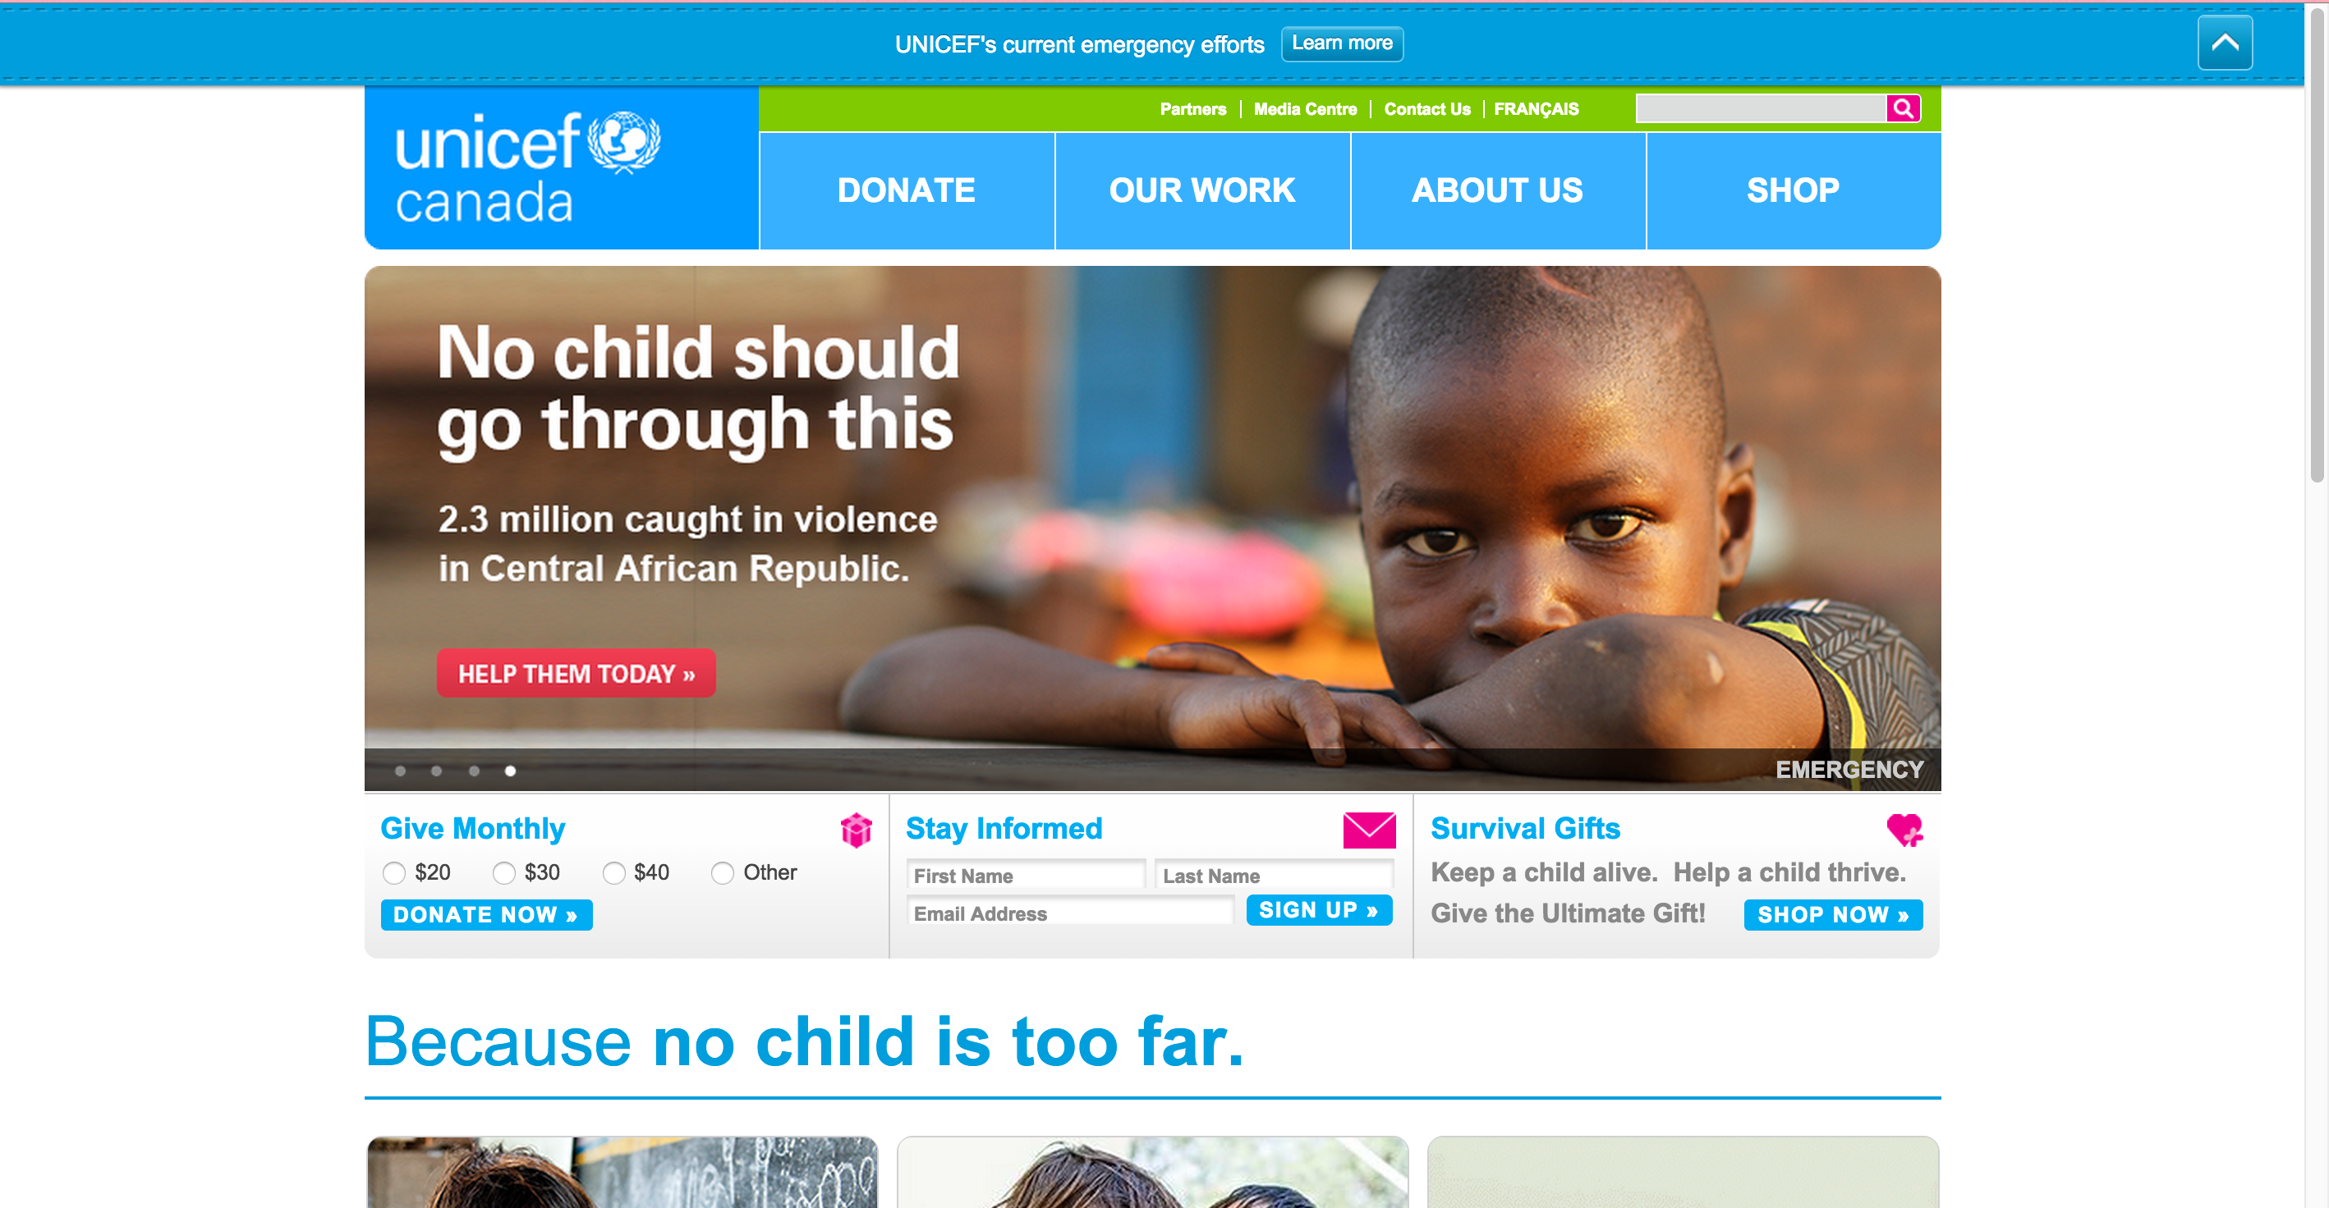

**The Snowsuit Fund**

<http://snowsuitfund.com/>

* banner image focuses on the donating aspect of the organization
* multiple tabs that lead to donating page
* captivating images with strong tag lines
* easy step by step on how to donate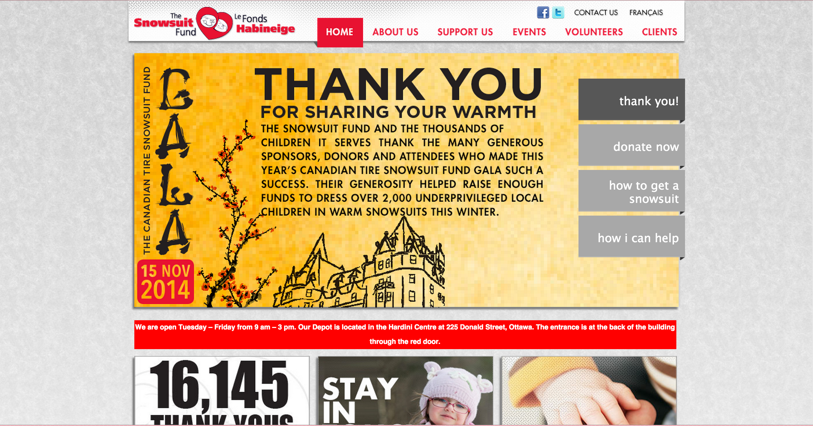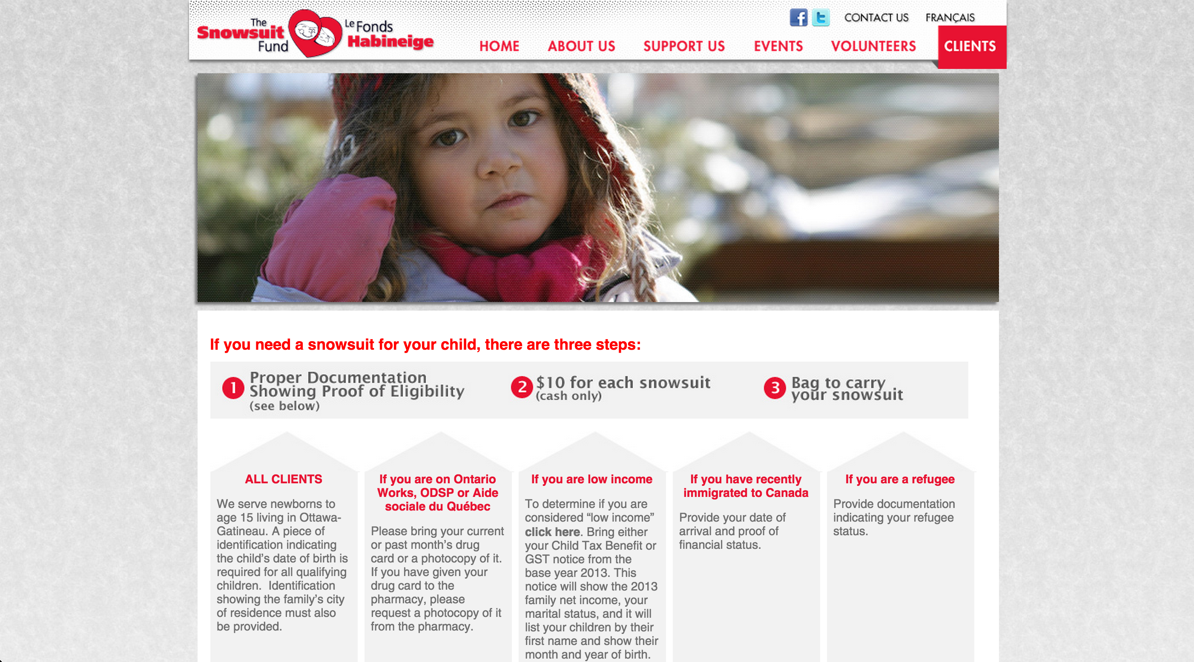

**Online Store - Home Depot**

<http://www.homedepot.ca/>

* Slider image banner showcasing recommended products to buy
* Side panel with list of categories for available products
* Login tab at top to keep track of purchases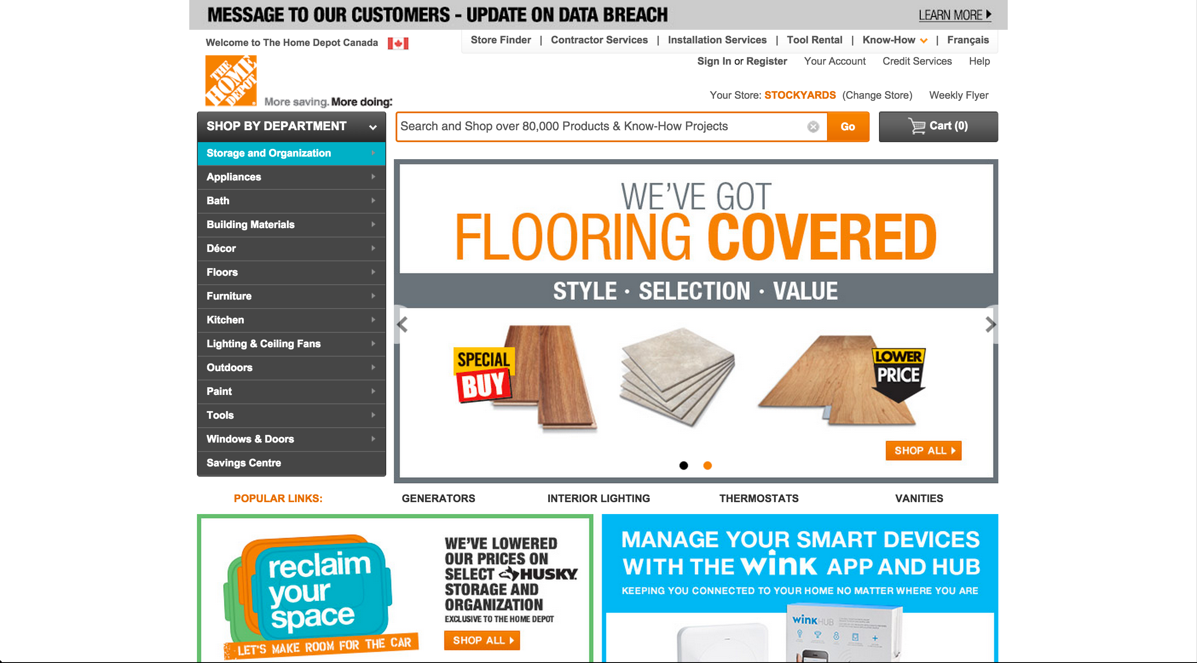

**Online Store - Ikea**

http://www.ikea.com/ca/en/?cid=ca|ps|exact|go|corp2008

* Login tab at top of website
* Banner image showcasing recommended products to buy
* Grid with images of products, categories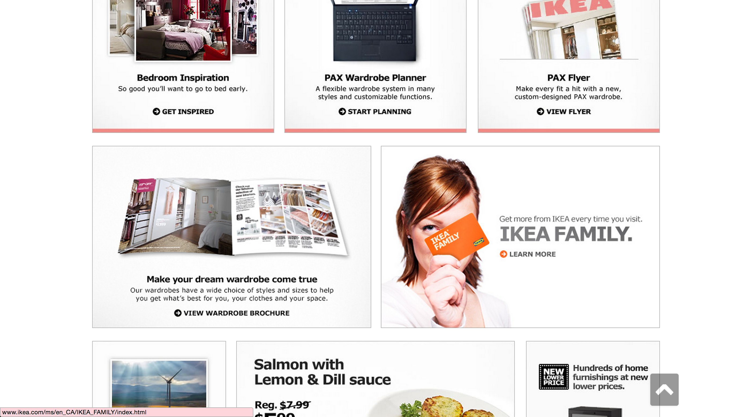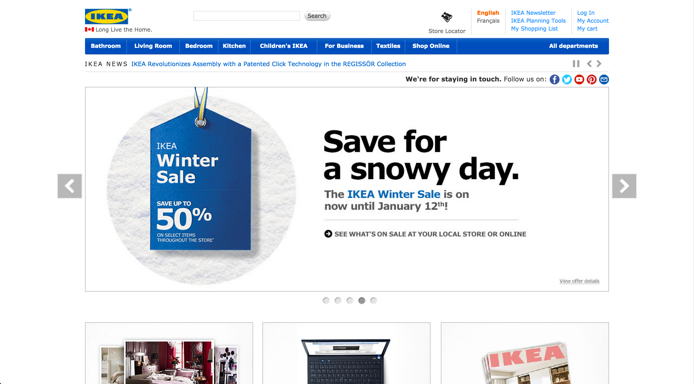

**Canadian Red Cross**

<http://www.redcross.ca/>

* Donate button is stands out amongst all other elements
* Donation box is second element on the website
* Banner image showcasing what they do
* Donation chart